**Batch:C3-3 Roll No.:16010122221**

**Experiment / assignment / tutorial No. 1**

**Grade: AA / AB / BB / BC / CC / CD /DD**

**Signature of the Staff In-charge with date**

|  |
| --- |
| **TITLE:** Write a program for:  a. Program to find area and circumference of various Geometric shapes.  b. Program to calculate EMI (Equated Monthly Instalment) of loan amount if principal, rate of interest and time in years is given by the user.  (E = (P.r.(1+r)n) / ((1+r)n – 1) |

**AIM:** Write a program for:

a. Program to find area and circumference of various Geometric shapes.

b. Program to calculate EMI (Equated Monthly Instalment) of loan amount if principal, rate of interest and time in years is given by the user.

E = (P.r.(1+r)n) / ((1+r)n – 1)

**____________________________________________________________**

**Expected OUTCOME of Experiment:**

1. We get the area and circumference of a circle

b. We get the EMI (Equated Monthly Instalment) of loan amount if principal, rate of interest and time in years is given by the user.

E = (P.r.(1+r)n) / ((1+r)n – 1)

**__________________________________________________________**

**Books/ Journals/ Websites referred:**

1. Programming in ANSI C, E. Balagurusamy, 7 th Edition, 2016, McGraw-Hill Education, India.
2. Structured Programming Approach, Pradeep Dey and Manas Ghosh, 1 st Edition, 2016, Oxford University Press, India.
3. Let Us C, Yashwant Kanetkar, 15th Edition, 2016, BPB Publications, India.

**_____________________________________________________________________**

**Problem Definition:**

Problem 1 : Area and Circumference of any shape(**will be given by instructor**) (example Circle)

Ask the user to enter the value of the radius of a circle.  Put the values in the formula for finding area of a circle and circumference of a circle and print the outcome for area of a circle and circumference of a circle

Problem 2: Calculating EMI

Ask the user to enter the value of principal amount, rate of interest and time (in years).Store the value in E and print the final monthly instalment E as an outcome.

Formula to be used: (E = (P.r.(1+r)n) / ((1+r)n – 1)

**Flowchart:**

**Implementation details:**

**PROBLEM 1 - AREA OF CIRCLE.**

#include <stdio.h>

int main()

{

float r;

printf("Enter the Radius of Circle");

scanf("%f",&r);

printf("Area of the circle is %f",3.14*r*r);

return 0;

}

**CIRCUMFERENCE OF CIRCLE.**

#include <stdio.h>

float PI = 3.14;

int main()

{

    float radius, ci;

    printf("\nEnter the radius of the circle : ");

    scanf("%f", &radius);

    ci = 2*PI*radius;

    printf("\nCircumference of Circle : %f", ci);

    return 0;

}

**PROBLEM 2 - CALCULATING OF EMI.**

#include <stdio.h>

#include<math.h>

int main()

{

float p, R, r, emi;

int n;

printf("Enter principal amount: ");

scanf("%f", &p);

printf("Enter annual interest rate: ");

scanf("%f", &R);

printf("Enter number of months: ");

scanf("%d", &n);

r = R/(12*100);

emi = p * r * pow(1+r,n)/(pow(1+r,n)-1);

printf("Monthly EMI: %f", emi);

return 0;

}

**Output(s):**

**OUTCOME FOR AREA OF CIRCLE.**

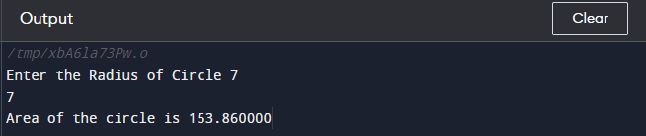

**OUTCOME FOR CIRCUMFERENCE OF CIRCLE.**

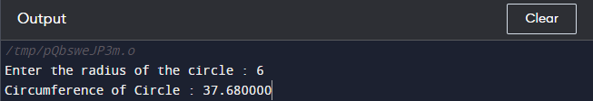

**OUTCOME FOR EMI.**

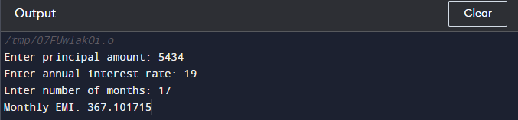

**Conclusion:**

With the help of these codes we realize that simple calculations like calculating the area or circumference of any shape. Complex calculations like EMI can also be done with the help of coding and it can make our life easier day by day.

**Post Lab Descriptive Questions**

1. **What are the basic data types in C?**

Ans: Integer, Float, Void, Character, Double

1. **What is a flowchart? What are the standard symbols used to draw a flowchart ? Explain in brief.**
2. Basic data types in C are as follows:-

Floating-point, integer, double, character.

1. Flowchart are special shapes to represent different types of actions or steps in a process. Lines and arrows show the sequence of the steps, and the relationships Among them. These are known as flowchart symbols. Some standard symbols of flowchart are:

* Flow line: Shows the process’ direction. Each flow line connects two blocks.
* Terminal Symbol:  Indicates the beginning or end of a flowchart.
* Process: Represent a step in a process. This is the most common

component of a flowchart.

* Decision Symbol: Shows a step that decides the next step in a process.

This is commonly a yes/no or true/false question.

* Input/Output: Indicates the process of inputting or outputting external

data. This is indicated by the shape of a parallelogram

* Annotation/Comment: Indicates additional information regarding a step in

a process.

* Predefined process: Shows named process which is defined elsewhere.
* On- page connector symbol: are pairs of on-page connector are used to

replace long lines on a flowchart page.

‍

**Date: _____________ Signature of faculty in-charge**